
Grey & Associates
Party Wall Surveyors
{{ao_surveyor}}
{{aos_add_vert}}
{{currdate}}
Dear {{aos_firstname}},

{{ten_day_letter_subject}}

There has been no meaningful progress on these matters. I believe that you have neglected to act effectively under Section 10(7) of the Party Wall etc Act 1996 and request that effective and meaningful action is taken within ten days of the date of service of this letter.

Kind regards,
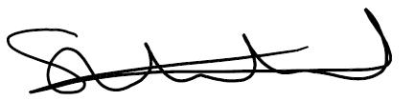
______________________
Steve Whitehead
Grey & Associates Ltd
T: 020 8150 3762
E: steve.w@greyandassociates.co.uk

“Could saving a few pounds now cost thousands in legal bills later?”

